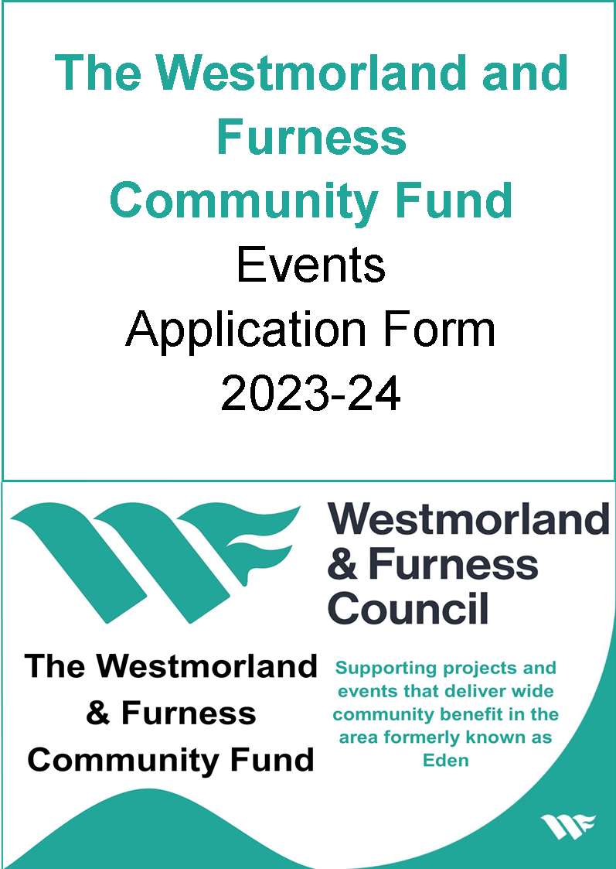

The Westmorland and Furness Community Fund Events Application Form 2023-24
Please note that the Westmorland and Furness Community Fund is only eligible for projects and events within the area formerly known as Eden. For further clarity on this, please contact the Communities and Wellbeing Team.
Please ensure that you have also read and understood the notes; ‘Guide to the Criteria, Application Process and Conditions of Funding’ before completing an application form. This can be found by clicking here
Our Communities and Wellbeing Team would welcome a conversation regarding the eligibility of your project before you make an application or if you require a copy in an alternative format or language. This can be done by emailing edencommunityfund@westmorlandandfurness.gov.uk or contacting 0300 373 3300 and requesting to speak Jess Houghton or Matty Buck.
Please note there are two different application forms; one for projects and one for community events. This guide applies to community events.

Brief Overview
- The maximum grant that can be applied for is £5,000
- Your group must have its own bank account and constitution or governing document
- You need at least 20% match funding
- You must provide all supporting documents with your application
- Grants are paid 75% in advance and 25% on completion

Section 1: Contact Details

1a. Name of group/ organisation
1b. Contact name
1c. Contact address
1d. Postcode
1e. Daytime telephone number
1f. Mobile number
1g. Email
1h. Your position in the group

Section 2: About your Group/Organisation

2a. What year was your group/organisation formed?
2b. Website address of your group/organisation (if you have one)
2c. Please give a brief description of your group/organisation
(What type of group are you? What are your aims and what do you do?)
Maximum 100 words
2d. Charity Registration Number
2e. How many trustees/members of the management committee do you have?
2f. How many volunteers do you have?
2g. How many paid staff do you have?
2h. Please give details of any previous successful application to the former Eden District Council Community Fund (include the date the grant was awarded, the amount awarded and what the grant was for).
Maximum 100 words
2i. Details of two unrelated bank/building society signatories
Name of signatory 1: | Address of signatory 1:
Name of signatory 2: | Address of signatory 2:

Section 3: Your Community Event

3a. Name of your event
3b. Date/s of event
3c. Location of event (including postcode if relevant). Events must be located within the area formerly known as Eden.
Maximum 100 words
3d. Which geographical area will benefit from your event?
Maximum 100 words

3e. What event/activities do you want us to help fund? Be specific about what you will do, how you will do it (including any voluntary input) and what you would spend the grant on.
Maximum 200 words
3f. Who is invited/eligible to attend your event? (Which communities, groups, geographical areas?)
Maximum 100 words

3g. What evidence do you have to show that your event will contribute to local priorities in your area? For example; Community Led Plans or Westmorland and Furness’ Corporate Plan.
Maximum 200 words
3h. What evidence do you have to show that your event is needed by the local community? For example consultations, letters of support etc.
Maximum 200 words

3i. | Will there be an admission charge? | Yes/No | 3j. | If there is to be a charge, what will it be? |  | Adult | £
 |  |  |  |  |  | Child | £
 |  |  |  |  |  | Concession | £
3k. | What will happen to proceeds from the admission charge?
Maximum 100 words
3l. | Has this event taken place before? (Please note the same activity will not be funded twice). |  |  |  | Yes/No  If ‘No’ please go to question 3p.
3m. | If this event has taken place before, when was it last held?
3n. | Is this an annual event? |  |  |  | Yes/No
3o. | If applying for a regular event, what is different about this one?
Maximum 100 words

3p. How will you promote and publicise your event?

Maximum 200 words
3q. What is the change or difference your event will make? (eg stronger communities, increased volunteering and participation or reduced rural isolation)
Maximum 200 words

Section 4: Financing your Event

4a. What is the total cost of your event including VAT? | £
4b. What is the total cost of your event excluding VAT? | £
4c. How much funding are you applying for from the Eden District Council Community Fund? (There is a minimum grant level of £200 and a maximum of £5,000.) | £
4d. What is your total match funding from other sources? (must be at least 20% of total cost) | £
4e. Is your organisation VAT registered? | Yes No
4f. VAT registration number (if relevant)

4g. Are you intending to claim VAT back?  If ‘yes’ any grant that we offer will be up to 80% of the total project costs minus the reclaimable VAT. Please ensure that you state the figure for the reclaimable VAT under ‘Reclaimable VAT’ in section 5b. | Yes No

Section 5: Event Budget

5a. Projected Expenditure
Item Description | Cost excluding VAT | VAT | Total including VAT
 | £ | £ | £
 | £ | £ | £
 | £ | £ | £
 | £ | £ | £
 | £ | £ | £
 | £ | £ | £
 | £ | £ | £
 | £ | £ | £
 | £ | £ | £
 | £ | £ | £
 | £ | £ | £
Total | £ | £ | £

5b. Projected Income (total projected expenditure and total projected income should be the same)
Source of Income |  | Confirmed  Amount | Unconfirmed Amount
Westmorland and Furness Community Fund (maximum 80% of total costs) |  |  | £
Group’s own cash contribution |  |  | £
In-kind volunteer time (calculated at £9.90 per hour).  This cannot exceed 10% of total cost |  |  | £
In-kind materials |  |  | £
Admission fees |  |  | £
Reclaimable VAT (if applicable) |  |  | £
List of other grants or funders below |  |  | £
 |  |  | £
 |  |  | £
 |  |  | £
 |  |  | £
 |  | Total | £
5c. Contributions In-kind - Voluntary contributions of time or materials can help to demonstrate the community value of your project. Please give details below.
In-kind volunteer time - If you have included volunteer time in your projected income, please describe what this will consist of and how it will contribute to your event/ activity. Please supply a timesheet for the volunteers’ time.
 | Maximum 100 words
In-kind materials - If you have been offered free or discounted materials for your event/activity, please describe what these materials are and how they contribute toward your event.
 | Maximum 100 words

Section 6: Safeguarding

6a. Does your group/organisation have a child protection policy or statement? (Please enclose a copy with this application if relevant to your event or activity).
6b. Does your group/organisation have a safeguarding vulnerable adults policy or statement? (Please enclose a copy with this application if relevant to your event or activity.)
6c. What arrangements will be made for those with access difficulties to participate in your event? (This will include people who use wheelchairs, the visually impaired, the hard of hearing or people on low incomes?)
Maximum 100 words
6d. How will you actively seek to involve as wide a range of people as possible from different backgrounds (eg gender, age range, ethnicity, religion, rurally isolated etc?)
Maximum 100 words

Section 7: Supporting Documentation Checklist

Please supply all required supporting documents when you submit your application. Your application will not be considered until you have supplied all the documentation below.
A copy of your most recent annual accounts
A copy of your most recent bank or building society statement (not more than three months old) to include any reserve accounts.
Copies of two written quotes/estimates for all items of expenditure between £50 and £2,500 (not more than six months old).
Copies of three written quotes/estimates for all items of expenditure above £2,500 (not more than six months old).
Copies of Equality Policies or Statement (if applicable to your application).
Copies of Safeguarding Policies or Statement (if applicable to your application).
A copy of your constitution or governing document

Section 8: Declaration

In signing this declaration I agree that:
- I have full authority on behalf of the group/organisation to make this application.
- I have read and understood the ‘Guide to the Criteria, Application Process and Conditions of Funding’ and agree to the conditions of funding.
- The information contained in this application is correct at the time of submission.
- I will complete and return aa Event Completion Form within three months of completion of our event in order to draw down the final 25% grant payment.
- The group/organisation will have appropriate insurance cover for the event.
Signed * | Print name | Position in group (chair etc)
Date

* We can accept a typed signature if the person signing is the same person who submits the application by email (if not we will require a signed hard copy).

Section 9: Data Protection
The information you have provided in your application will only be used for the purposes of considering your grant application. If your application is successful, the name of your group, the location of the project, amount awarded and a summary of your project will appear in a public committee report and may also appear on the Council’s website and in other media.
We may occasionally wish to share your contact details with other local community groups and organisations and they may wish to contact you - can we pass on your details?
Yes No

Section 10: Returning your Application
Please enclose all required supporting documentation and return your completed form to:
Email: edencommunityfund@westmorlandandfurness.gov.uk
Address:
Communities and Wellbeing Team
Westmorland and Furness Council
Mansion House
Penrith
CA11 7YG
Telephone: 0300 373 3300
Upcoming deadlines can be found on our website or by using the contact details above.
Personal data and privacy
We are committed to protecting your personal data and privacy. We will use the information you supply on this form for the purposes of providing you with Council services. We may share your information within the Council and with our contractors and partners, who help to deliver our services. We will only keep your personal data for as long as necessary for the purpose/s you provided it. For more information on how we protect your personal data, see our Privacy Policy (opens in a new window).

