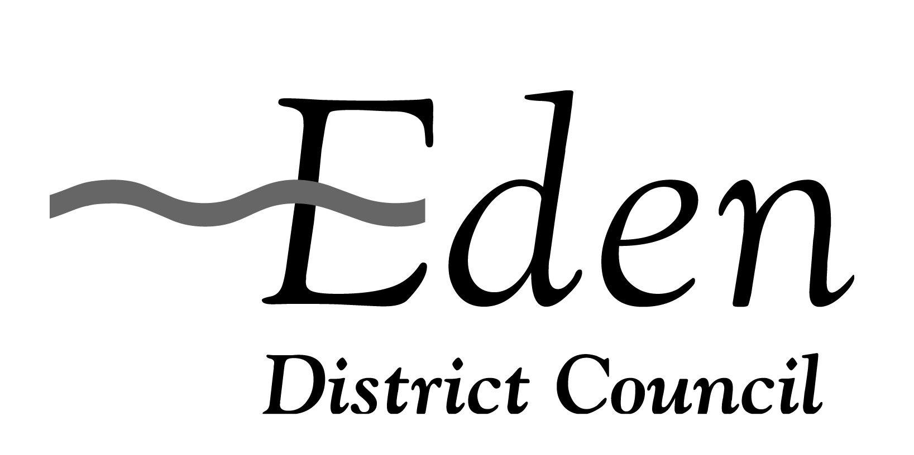
Application to Licensing Section App No
Eden District Council, Town Hall, Penrith, CA11 7QF Office use only

Declaration for a club premises certificate to be granted under the Licensing Act 2003
PLEASE READ THE FOLLOWING INSTRUCTIONS BEFORE COMPLETING DECLARATION
Before completing this form please read the guidance notes at the end of the form.
If you are completing this form by hand please write legibly in block capitals. In all cases ensure that your answers are inside the boxes and written in black ink. Use additional sheets if necessary.
You may wish to keep a copy of the completed form for your records.
Club Premises details
Name of club

Postal address of club, if any, or, if none, ordnance survey map reference or description

Post Town | Postcode
Telephone number (if any)
E-mail (optional)
CLUB DECLARATION AS TO QUALIFYING CLUB STATUS
(Insert name of club)
club makes the following declarations
- Where the club to which this application relates is:
a registered society within the meaning of the Industrial and Provident Societies Act 1965, a registered society within the meaning of the Friendly Societies Act 1974 or a registered friendly society within the meaning of the Friendly Societies Act,

the club declares that the club satisfies:
Please tick Yes
Condition 1 in section 62(2) of the Licensing Act 2003

Please give relevant club rule number(s)

Condition 2 in section 62(3) of the Licensing Act 2003

Please give relevant club rule number(s)

Condition 4 in section 62(5) of the Licensing Act 2003

Does the club wish to supply alcohol to members and guests?
If yes the club declares that -

The purchase of alcohol for the club and the supply of alcohol by the club
is under the control of the members or of a committee appointed by the
members

Please give relevant club rule number(s), if any

- Where the club to which this a3plication relates is:
an association organised for the social well-being and recreation of persons employed in or about coal mines, the club declares that the club satisfies:
Please tick Yes
Condition 1 in section 62(2) of the Licensing Act 2003

Please give relevant club rule number(s)

Condition 2 in section 62(3) of the Licensing Act 2003

Please give relevant club rule number(s)

Does the club wish to supply alcohol to members and guests?
If yes the club declares that it satisfies -

First condition in section 66(4) of the Licensing Act 2003
Please give relevant club rule number(s), if any

Second condition in section 66(5) of the Licensing Act 2003
Please give relevant club rule number(s), if any

- Where the club to which this application relates does not fall into the categories in 1 or 2 above, the club declares that the club satisfies:
Please tick Yes

Condition 1 in section 62(2) of the Licensing Act 2003

Please give relevant club rule number(s)

Condition 2 in section 62(3) of the Licensing Act 2003

Please give relevant club rule number(s)

Condition 3 in section 62(4) of the Licensing Act 2003

The club’s arrangements for restricting the club’s freedom of purchase of alcohol are:

- contained in club rule number(s),

- or, as follows

(please provide a short description)

The club’s provisions by which money or property of the club or any gain arising from the carrying on of the club is or may be applied for charitable benevolent or political purposes are:

- contained in club rule number(s),

- or, as follows

(please provide a short description)

The arrangements for giving members information about the finances of the club are:

- contained in club rule number(s),

- or, as follows

(please provide a short description)

Please describe details of the books of account and other records kept to ensure the accuracy of the information about finances given to members of the club or give the relevant rule number(s)
Please tick Yes

Condition 4 in section 62(5) of the Licensing Act 2003

Condition 5 in section 62(6) of the Licensing Act 2003

The club proposes to supply alcohol to members and guests
and declares that the club satisfies:

additional condition 1 in section 64(2) of the Licensing Act 2003

Please give relevant club rule number(s), if any

additional condition 2 in section 64(3) of the Licensing Act 2003

Please give relevant rule number(s), if any

additional condition 3 in section 64(4) of the Licensing Act 2003

Please give relevant club rule number(s), if any

IT IS AN OFFENCE, UNDER SECTION 158 OF THE LICENSING ACT 2003, TO MAKE A FALSE STATEMENT IN OR IN CONNECTION WITH THIS APPLICATION. THOSE WHO MAKE A FALSE STATEMENT MAY BE LIABLE ON SUMMARY CONVICTION TO A FINE OF ANY AMOUNT.
I | ,
make this declaration on behalf of the club and have authority to bind the club
Signature …………………………………………………………………………………………………

Date
…………………………………………………………………………………………………

Capacity
…………………………………………………………………………………………………
As a public body, we are under a duty to protect the public funds that we administer, and to this end may use the information you have provided on this form for the prevention and detection of fraud. We may also share this information with other bodies responsible for auditing or administrating public funds for these purposes.

